1. Translated to DFA:
   1. 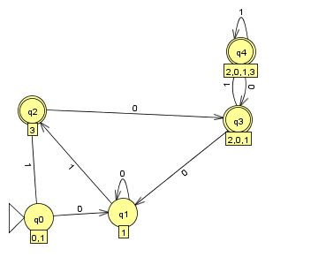
2. This is a Regular language, it can be solved by the following DFA:
   1. 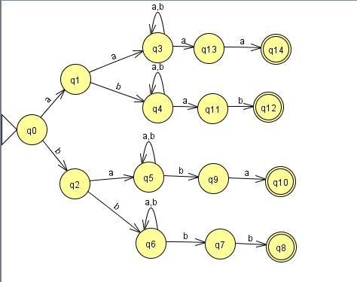
3. Let E = 01\* + 10\*.

E^R = (01\* + 10\*)R = (01\*)R + (10\*)R

= (1\*)^R 0^R + (0\*)^R 1^R

= (1^R)\*0 + (0^R)\*1

= 1\*0 + 0\*1.

* 1. R=a((b + c)\* a (b + c)\* a (b + c)\* a)\*
  2. R= (a+b)\* aa
  3. R=(b)\* (a+λ) (b)\* (a+λ) (b)\* (a+λ) (b)\*
  4. (‘+’ + ’-’ + λ) (1 + 2 + 3+4+5+6+7+8+9) (0+1 + 2 + 3+4+5+6+7+8+9)\* e (‘+’ + ’-’ + λ) (0+1 + 2 + 3+4+5+6+7+8+9)\*
  5. S → BaB
     1. B → bB|λ
  6. S → bS
     1. S → aB
     2. B→ λ
     3. A → aS
     4. B → aA
     5. A → bA
     6. B →bB